Robert Breckenridge CMSC403 Programming Languages A1 Grammar Rules

This is the entry point for all programs:  
Each program has at least one statement.

prog.jpg

Each statement consists of keyword and identifiers that act as a “signature” what to look for

followed by and assignment operator or “=” then an e or “expr”.  
  
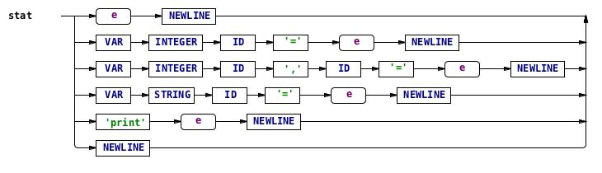

Expressions are evaluated from each left and right child node in the parse tree.

